Course Work Project Description and Rubric
Semester | 202510 |  | Division |  | CIS
Assessment title in Syllabus | Project |  | Program |  | IT and IS
1
Course Code | CDS 2413
Course Title | Programming for Data Science
CLOs | All CLOs |  | Accreditation Body |  | CAA & CIPS
Course Instructor |  |  | CRN
Assessment Weight | 40% |  | Submission Date |  | Week 14
For Group Work submissions an additional individual assessment will be conducted.
Grades for the students in one group will vary based on the individual performance in the additional assessment.
Student Declaration:
Academic Integrity Statement
In accordance with the HCT Academic Integrity Policy
• Students are required to refrain from all forms of academic integrity breaches as defined and explained by HCT.
• A student found guilty of having committed acts of academic integrity breach(es) will be subject to the relevant sanctions as outlined by HCT.
إفادة النزاهة الأكاديمية
وفقًا لسياسة كليات التقنية العليا للنزاهة الأكاديمية
• على الطلبة الإلتزام بلوائح وقواعد النزاهة الأكاديمية، كما هو مبيّن وموضح في السياسات والإجراءات الخاصة بكليات التقنية العليا.
• في حالة ارتكاب الطالب أي شكل من أشكال الإخلال بالنزاهة الأكاديمية، سيتعرض الى العقوبات الموضحة في السياسات ذات الصلة.
This assignment is entirely my own work except where I have duly acknowledged other sources in the text and listed those sources at the end of the assignment. I have not previously submitted this work to the HCT, or any other entity. I understand that I may be orally examined on my submission.
Student (s) Signature: ___________________________________
___________________________________________

Student Name(s): | Rwaan Rashed | Moza Ghareeb |  | Saeed Easa
Student HCT ID(s): | H00532383 | H00531637 |  | H00389993

For Examiner’s Use Only
 | Group (50%) |  |  |  |  | Individual (50%)
CLO | 1 | 2 | 3 | 4 | Report Formatting | Oral Defense | Anaconda Certificate | Total | %
Marks Allocated | 10 | 10 | 42 | 26 | 12 | 40 | 10 | 100 | 40
Marks Obtained

Shopping Behavior Dataset:-

1. Purpose of Data Analysis
The purpose of analyzing this dataset is to understand customer shopping patterns and behavior.
Key goals:
- Identify what factors (age, gender, discount, subscription, etc.) influence purchase amount.
- Segment customers based on frequency, previous purchases, and product categories.
- Predict customer behavior, e.g., likelihood of making a high-value purchase.
- Support marketing decisions like promotions, personalized recommendations, and loyalty programs.
2. Type of Programming Used
Identification: The dataset of shopping behavior is analyzed using Python programming.
Justification:
- Data Handling: Python has pandas to read and organize the CSV data easily into tables (DataFrames).
- Math & Statistics: It has numpy(for numerical calculations), and scipy(Scientific Python) for calculations, averages, probabilities, etc.
- Visualization: With matplotlib and seaborn, we can make graphs to see shopping patterns (like purchase frequency, gender, age groups).
- Machine Learning: Python has scikit-learn for predicting customer behavior and trends.
- Easy & Popular: It is simple to learn, widely used in real-world Data Science projects, and supported everywhere (including Jupiter Notebook).

3. Type & Purpose of Machine Learning Algorithm
For this dataset, a suitable machine learning algorithm is:
- Regression (e.g., Linear Regression, Decision Tree Regressor) if the goal is to predict purchase amount.
- Classification (e.g., Logistic Regression, Random Forest, KNN) if the goal is to
predict customer behavior, such as:
- Will the customer use a promo code?
- Will the customer purchase frequently (Weekly vs. Annually)?
Example choice: Classification with Random Forest to predict whether a customer is a frequent buyer based on age, gender, subscription status, discounts, etc.
Purpose: Helps businesses target frequent customers with offers and convert occasional buyers into loyal ones.

4. Independent & Dependent Variables
Dependent Variable (Target): Could be “Purchase Amount (USD)” if we are predicting how much a customer will spend (regression). OR “Age Group” if we are predicting the customer’s age category (classification).

Independent Variables (Features):
- Demographics: Age, Gender, Location
- Shopping behavior: Previous Purchases, Subscription Status, Discount Applied, Promo Code Used
- Product details: Category, Size, Season, Review Rating
- Transaction details: Payment Method, Shipping Type

5. Sampling: Type & Justification
Type of Sampling Used: Stratified Random Sampling
- We divided the dataset into strata (subgroups) based on Gender and Frequency of Purchases.
- Then, we randomly selected samples proportionally from each subgroup.
- This gave us 1000 rows (a smaller dataset) that still preserve the original ratios of Male/Female and Weekly/Monthly/Annual buyers.

Why Stratified Sampling is Best for This Dataset
- Customer Diversity:
  - The dataset contains different customer groups (Male/Female, frequent/occasional shoppers).
  - Stratified sampling ensures all groups are fairly represented in the sample.
- Prevents Bias:
  - If we used simple random sampling, we might accidentally get mostly male weekly buyers and miss annual female buyers.
  - Stratified sampling keeps the same proportions as the full dataset.
- Improves Accuracy:
  - Since shopping behavior depends strongly on frequency of purchases, gender, and age, stratified sampling ensures that predictions or insights from the sample are reliable and generalizable to the whole dataset.
Example of the shopping behavior dataset:
Full dataset: 68% Male, 32% Female; customers purchase Weekly, Monthly, Quarterly, Annually, etc. 1000-row sample: Maintains the same Male/Female ratio and ensures all purchase frequencies are represented. This way, the smaller sample reflects the true distribution of the original 3,900 records.
- Why We Used Two Different Dataset Sizes: 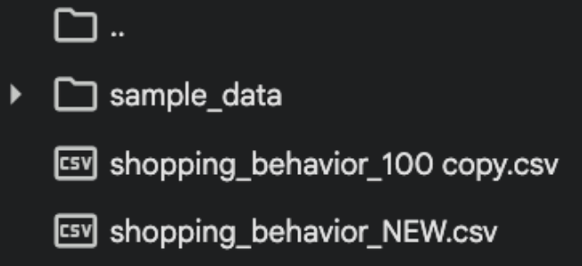
We used two versions of the Shopping Behavior dataset because each size served a different purpose. The 100-row dataset (shopping_behavior_100 copy.csv) was used mainly for visualizations; smaller data makes the graphs look clean, neat, and easy to read without too much crowding. The 1,000-row dataset (shopping_behavior_NEW.csv), on the other hand, was used for all calculations and statistical analysis because it gives more accurate, reliable results and represents the overall customer behavior better. Using both sizes helped us keep the graphs clear while still performing strong and detailed analysis.

Final Justification:
For customer behavior analysis, Stratified Random Sampling is the most suitable method because it balances representation across groups and reduces sampling error. This ensures that business insights (like which group spends more, who uses discounts, etc.) are accurate and unbiased.

Task 2

1. Justify why you want to perform the descriptive analysis for the chosen 1 dataset.
Descriptive analysis is done to understand the dataset in a clear and simple way. It helps to see how the data is distributed, what the averages and ranges are, and if there are any missing or unusual values. By doing this, we can check the quality of the data and make sure it is accurate before doing deeper analysis. It also helps to discover basic trends and patterns in customer behavior, which can guide the next steps such as feature selection and model building.

2. Create a script to develop a Python function for descriptive statistics. The input for the function should be the sample and the field to perform the descriptive statistics.
import pandas as pd
import numpy as np

ds = pd.read_csv('shopping_behavior_NEW.csv')

# Descriptive stat for all columns
ds.describe().T

# create a function to find the descriptive stat for the given field
from matplotlib.colors import Normalize
def Desc_stat(ds,var):
mean=ds[var].mean()
median=ds[var].median()
mode=ds[var].mode()
minimum=ds[var].min()
maximum=ds[var].max()
range=ds[var].max() - ds[var].min()
std_dev=ds[var].std()
variance=ds[var].var()
skew=ds[var].skew()
kurtosis=ds[var].kurt()
count=ds[var].count()
Quart = [
ds[var].quantile(0),
ds[var].quantile(0.25),
ds[var].quantile(0.50),
ds[var].quantile(0.75),
ds[var].quantile(1),
ds[var].quantile(0.75) - ds[var].quantile(0.25)
]

summary = {
"Average ": mean,
"Median ": median,
"Mode ": mode,
"Minimum ": minimum,
"Maximum " : maximum,
"Range ": range,
"Std Dev ": std_dev,
"Variance ": variance,
"Skewness ": skew,
"Kurtosis ": kurtosis,
"Minimum ": Quart[0],
"25th Pecentile ": Quart[1],
"50th Pecentile ": Quart[2],
"75th Pecentile ": Quart[3],
"Maximum ": Quart[4],
"Inter Quartile Range ": Quart[5],
"Count ": count
}
return summary

Output:
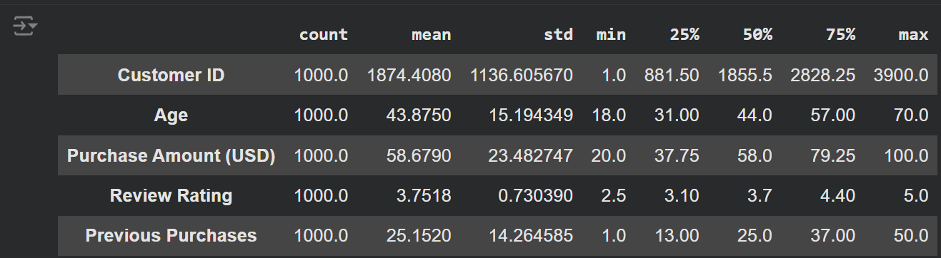

This code reads the dataset and calculates basic statistics like mean, median, and standard deviation. The output shows a table of these statistics for each column.

3. Create a program to randomly sample size 150 and find the descriptive statistics for the dependent variable from the sample [Apply the descriptive function which you created].
# (TASK 2) Q3: sample 150 rows and apply the function from Q2
import pandas as pd

from pathlib import Path
csv_path = Path("/content/shopping_behavior_NEW.csv") # used the original file that has big data since question asked for 150 as sample size

# 1) Load data
df = pd.read_csv(csv_path)

# 2) Choose dependent variable (change if needed)
dep_var = "Purchase Amount (USD)"

# 3) Take a random sample of size 150 (reproducible)
# Check if sample size is larger than the population
sample_size = 150
if sample_size > len(df):
print(f"Warning: Sample size ({sample_size}) is larger than the total number of rows ({len(df)}). Sampling the entire dataset.")
sample_size = len(df)

sample_150 = df.sample(n=sample_size, replace=False, random_state=42)

print(f"Original rows: {len(df)}")
print(f"Sample rows: {len(sample_150)}")

# 4) Apply the Task-2 function to the SAMPLE (not the full df)
from math import isnan # optional, if you want to check mode
# Re-define the descriptive_stats function if it's not available in the current session
def descriptive_stats(data, field):
"""Function to calculate descriptive statistics for a given column."""
s = pd.to_numeric(data[field], errors='coerce').dropna()

stats = {
"Count": s.count(),
"Mean": s.mean(),
"Median": s.median(),
"Mode": s.mode().iloc[0] if not s.mode().empty else np.nan,
"Minimum": s.min(),
"Maximum": s.max(),
"Range": s.max() - s.min(),
"Standard Deviation": s.std(),
"Variance": s.var(),
"Skewness": s.skew(),
"Kurtosis": s.kurt(),
"25th Percentile": s.quantile(0.25),
"50th Percentile": s.quantile(0.50),
"75th Percentile": s.quantile(0.75),
"Interquartile Range": s.quantile(0.75) - s.quantile(0.25)
}

return stats

stats_150 = descriptive_stats(sample_150, dep_var)

# 5) Show results
print(f"\nDescriptive statistics for SAMPLE (n={sample_size}) — '{dep_var}':")
for k, v in stats_150.items():
print(f"{k}: {v}")

Output:
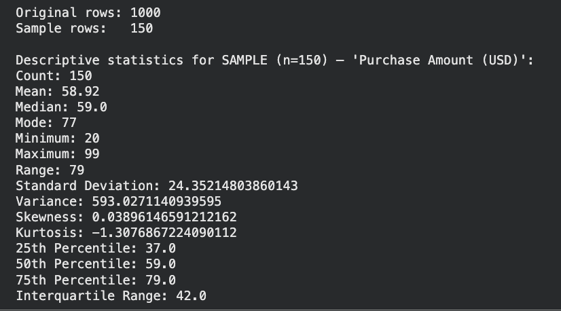

This code takes 150 random rows and calculates statistics for Purchase Amount. The output shows the sample’s mean, median, and other basic values.

4. Create a script for systematic sampling by giving certain conditions and finding the desc stat for the dependent variable from the sample [Apply the descriptive function which you created].
def systematic_sampling(data, step, start=0):
"""
Systematic sampling function
Condition: Select every kth record starting from specified position
"""
indices = np.arange(start, len(data), step)
return data.iloc[indices]

# Apply systematic sampling with conditions
step = 15 # Condition 1: Select every 15th record
start_pos = 3 # Condition 2: Start from the 4th record (index 3)

systematic_sample = systematic_sampling(ds, step, start_pos)

print("SYSTEMATIC SAMPLING WITH CONDITIONS")
print(f"Condition 1: Select every {step}th record")
print(f"Condition 2: Start from position {start_pos + 1} (index {start_pos})")
print(f"Original dataset size: {len(ds)}")
print(f"Systematic sample size: {len(systematic_sample)}")

# Apply descriptive function to dependent variable
dependent_variable = 'Purchase Amount (USD)'
systematic_stats = Desc_stat(systematic_sample, dependent_variable)

print(f"DESCRIPTIVE STATISTICS FOR DEPENDENT VARIABLE: {dependent_variable}")
for key, value in systematic_stats.items():
print(f"{key}: {value:.2f}")

Output:
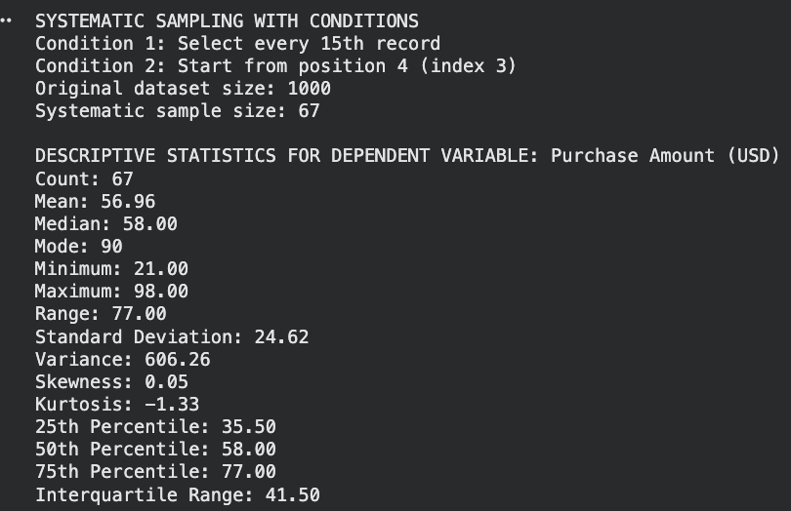

Selects every 15th row and calculates statistics for Purchase Amount. The output shows the sample size and simple statistics.

5. Create a detailed descriptive statistic report about the dependent variable of the chosen dataset.
import pandas as pd
import numpy as np
import matplotlib.pyplot as plt
from scipy import stats

# Choose dependent variable (edit if yours is different)
dep_var = "Purchase Amount (USD)"
# Choose dependent variable (edit if yours is different)
dep_var = "Purchase Amount (USD)"

desc = df[dep_var].describe()
extra = {
"variance": df[dep_var].var(ddof=1),
"skewness": df[dep_var].skew(),
"kurtosis": df[dep_var].kurt()
}
print("Descriptive Statistics for", dep_var)
print(desc)
print(extra)

Output: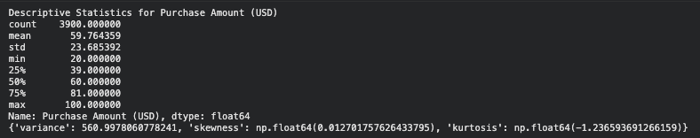
Gets the basic stats for Purchase Amount and also calculates variance, skewness, and kurtosis. The output shows all these values.

6: visualize the dependent variable by the graph/chart of the following using python program:
import pandas as pd
import matplotlib.pyplot as plt

# Load the data
df = pd.read_csv('/content/shopping_behavior_100 copy.csv') # Dataset size = 30

# Define variables
dep_var = "Purchase Amount (USD)"
indep_var = "Age"

# Scatter plot: Age vs Purchase Amount
plt.figure()
plt.scatter(df[indep_var], df[dep_var])
plt.title(f"Scatter Plot of {dep_var} by {indep_var}")
plt.xlabel(indep_var)
plt.ylabel(dep_var)
plt.tight_layout()
plt.show()

Output: 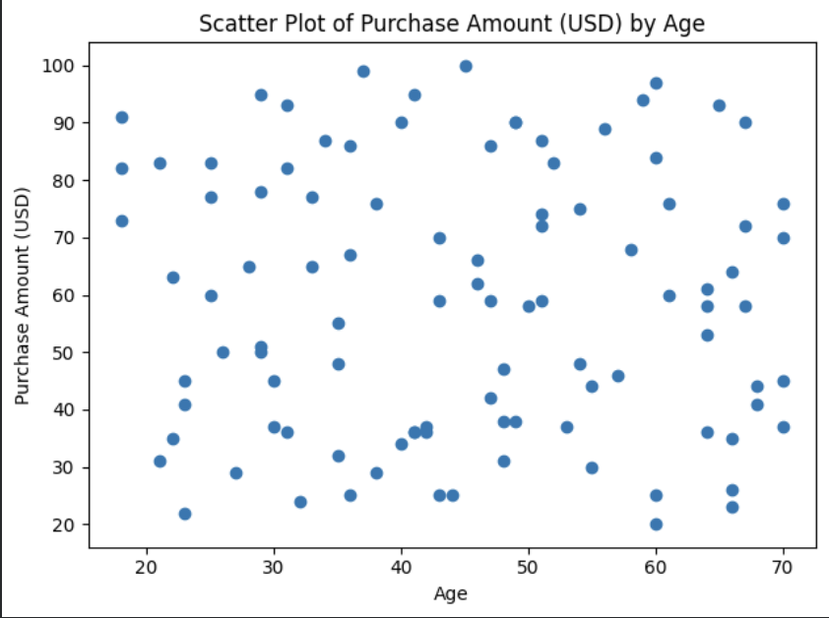

Makes a scatter plot of Purchase Amount across all rows. The output is a graph showing how the amounts change.

#B. Box Plot

# load the data
df = pd.read_csv('/content/shopping_behavior_100.csv') #data size = 1000

#Box plot
plt.figure()
plt.boxplot(df[dep_var].dropna(), vert=False)
plt.title(f"Box Plot of {dep_var}")
plt.xlabel(dep_var)
plt.tight_layout()
plt.show()

Output: 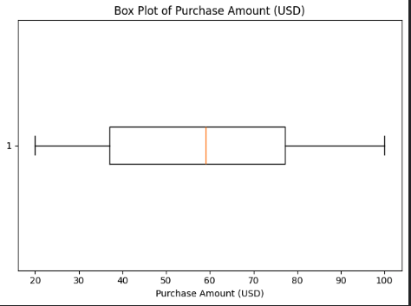
Creates a box plot for Purchase Amount. The output shows the median, spread, and outliers.

#C. Histogram

# load the data
df = pd.read_csv('/content/shopping_behavior_100.csv') #data size = 1000
#Histogram:
plt.figure()
plt.hist(df[dep_var].dropna(), bins=10, edgecolor='black')
plt.title(f"Histogram of {dep_var}")
plt.xlabel(dep_var)
plt.ylabel("Frequency")
plt.tight_layout()
plt.show()

Output: 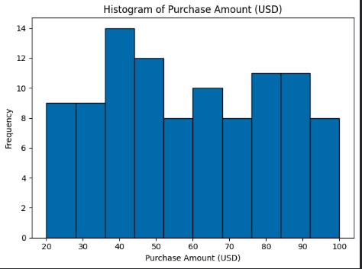
Creates a histogram of Purchase Amount. The output shows how often different purchase values appear.

#D. Heat Map:
num = df.select_dtypes(include=[np.number])
corr = num.corr(numeric_only=True)

plt.figure()
im = plt.imshow(corr, aspect='auto')
plt.title("Correlation Heat Map (Numeric Features)")
plt.xticks(range(len(corr.columns)), corr.columns, rotation=45, ha='right')
plt.yticks(range(len(corr.index)), corr.index)
plt.colorbar(im)
plt.tight_layout()
plt.show()
Output: 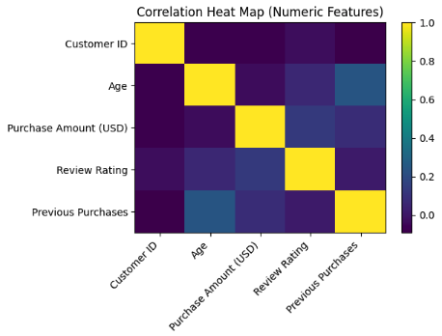
It shows the correlation between numeric features. The output is a heat map showing which variables are related.

7. Hypothesis Test Conclusion:
The hypothesis tests were conducted to examine the relationship between the independent and dependent variables in the dataset.
The Pearson and Spearman correlation tests were used to measure the relationship between Age and Purchase Amount (USD).
Both tests produced correlation coefficients of –0.01 with p-values above 0.05 (p = 0.515 and p = 0.514), indicating no significant relationship between age and purchase amount. This means that changes in customer age do not meaningfully affect how much they spend.
The Chi-Square test was used to test the association between Gender and Purchase Amount.
The test returned a Chi-square value of 0.05 and a p-value of 0.819, which is greater than 0.05, showing no significant association between gender and spending behavior.
Overall, the results suggest that neither Age nor Gender have a significant influence on the Purchase Amount in this dataset.
Code:
import pandas as pd
from scipy.stats import pearsonr, spearmanr, chi2_contingency
import numpy as np

# load the data
df = pd.read_csv('shopping_behavior_updated1.csv')

# - NUMERICAL TESTS:
# Age (independent) vs Purchase Amount (dependent)
x = df['Age']
y = df['Purchase Amount (USD)']

# Pearson test (linear relationship)
pearson_r, pearson_p = pearsonr(x, y)

# Spearman test (rank/monotonic relationship)
spearman_r, spearman_p = spearmanr(x, y)

print("Numerical Correlation Tests: ")
print(f"Pearson Correlation: {pearson_r:.2f}, p-value: {pearson_p:.3f}")
print(f"Spearman Correlation: {spearman_r:.2f}, p-value: {spearman_p:.3f}")

if pearson_p < 0.05:
print("Pearson: There IS a significant relationship between Age and Purchase Amount.")
else:
print("Pearson: There is NO significant relationship between Age and Purchase Amount.")

if spearman_p < 0.05:
print("Spearman: There IS a significant relationship between Age and Purchase Amount.")
else:
print("Spearman: There is NO significant relationship between Age and Purchase Amount.")

# - CATEGORICAL TEST:
# Gender (independent) vs Purchase Amount level (High/Low)
df['_PurchaseLevel'] = np.where(df['Purchase Amount (USD)'] >= df['Purchase Amount (USD)'].median(), 'High', 'Low')

# Create contingency table
table = pd.crosstab(df['Gender'], df['_PurchaseLevel'])

# Chi-square test
chi2, p_chi, dof, exp = chi2_contingency(table)

print()

print("Categorical Test (Chi-Square): ")
print(f"Chi-square value: {chi2:.2f} | p-value: {p_chi:.3f}")

if p_chi < 0.05:
print("Chi-Square: There IS a significant relationship between Gender and Purchase Amount.")
else:
print("Chi-Square: There is NO significant relationship between Gender and Purchase Amount.")
Output: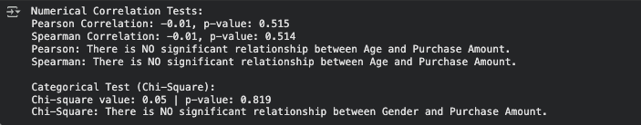

8. One-Sample T-Test using population mean from full dataset
# Q8: One-Sample T-Test using population mean from full dataset

import pandas as pd
import numpy as np
from scipy import stats

df = pd.read_csv("shopping_behavior_updatedNEW.csv")

def systematic_sampling(data, step, start=0):
indices = np.arange(start, len(data), step)
return data.iloc[indices]

step = 15
start_pos = 3
systematic_sample = systematic_sampling(df, step, start_pos)

# Select dependent variable
dep_var = "Purchase Amount (USD)"

# Population mean from the full dataset
population_mean = df[dep_var].mean()

# Sample values from the systematic sample
sample_values = systematic_sample[dep_var].dropna()

# Perform one-sample t-test
t_stat, p_value = stats.ttest_1samp(sample_values, population_mean)

print("One-Sample T-Test Results")
print("--------------------------")
print(f"Population Mean: {population_mean:.2f}")
print(f"Sample Mean: {sample_values.mean():.2f}")
print(f"T-statistic: {t_stat:.4f}")
print(f"P-value: {p_value:.4f}")

# Interpretation
alpha = 0.05
if p_value < alpha:
print("Conclusion: The sample mean is significantly different from the population mean.")
print("The sample may not represent the normal population.")
else:
print("Conclusion: There is no significant difference between the sample and population mean.")
print("The sample represents the normal population.")

Output: 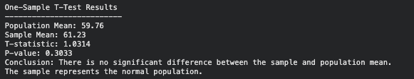
This code compares the sample mean to the population mean. The output shows the t-value, p-value, and whether the means are different.

Task 3
9. Build, Train, Develop and Evaluate using Simple Regression for chosen dataset.

# Define independent (X) and dependent (Y) variables
X = ds.iloc[:,[15]].values # independent variable (Previous Purchases)
y = ds.iloc[:,5].values # dependent variable (Purchase Amount)

# Split data into train and test sets (80% / 20%)
from sklearn.model_selection import train_test_split
X_train, X_test, y_train, y_test = train_test_split(X, y, test_size=0.2)
print(X_train)
print(X_test)
print(y_train)
print(y_test)
# Training the Simple Linear Regression model on the Training set
from sklearn.linear_model import LinearRegression
regressor = LinearRegression()
regressor.fit(X_train, y_train)
# Predicting the Test results
y_pred = regressor.predict(X_test)
print(X_test)
print(y_pred)
regressor.predict([[34]])
Output:

Predicts Purchase Amount using Previous Purchases. The output shows the regression line, the model equation, R² score, and a prediction.
# Visualize the Training set results
plt.scatter(X_train, y_train, color = 'red')
plt.plot(X_train, regressor.predict(X_train), color = 'blue')
plt.title('Purchase Amount vs Previous Purchases (Training set)')
plt.xlabel('Previous Purchases')
plt.ylabel('Purchase Amount (USD)')
plt.show()

Output:
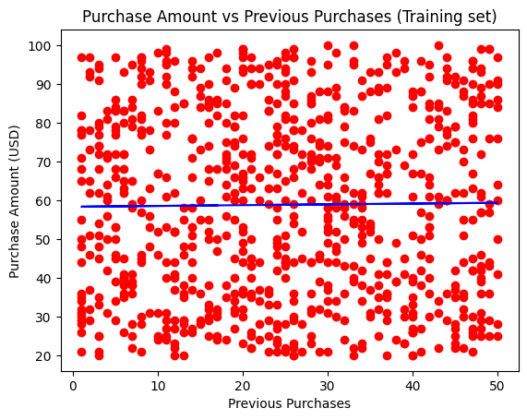

This code plots the training data as red dots and draws the blue regression line to show the model’s predictions. The output graph shows the actual values in red and the predicted trend in blue.
# get the intercept and the coefficent
b0 = regressor.intercept_
b1 = regressor.coef_
print('The intercept is:', b0)
print('The coefficent is:', b1[0])
Output:
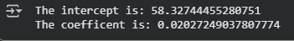

This code prints the model’s intercept and coefficient. The output shows an intercept of about 58 and a tiny coefficient of 0.02, meaning previous purchases barely affect the prediction.
from sklearn.metrics import r2_score

# model evaluation
r2_score(y_test, y_pred)
Output:
This code calculates the R² score. The output is 0.0018, showing the model fits the data very poorly.

10. Develop a script to forecast the value of the dependent variable from all the relevant independent variables using Multiple Linear Regression
# Importing the libraries
import pandas as pd
import numpy as np
from sklearn.model_selection import train_test_split
from sklearn.linear_model import LinearRegression

# Importing the dataset
dataset = pd.read_csv('shopping_behavior_NEW.csv')

# Splitting the dataset into the Training set and Test set
X = dataset[['Age', 'Review Rating', 'Previous Purchases']] # Independent variables
y = dataset['Purchase Amount (USD)'] # Dependent variable

X_train, X_test, y_train, y_test = train_test_split(X, y, test_size = 0.3, random_state = 42)

# Training the Multiple Linear Regression model on the Training set
regressor = LinearRegression()
regressor.fit(X_train, y_train)

# Predicting the Test set results
y_pred = regressor.predict(X_test)

# Getting the Final Multiple Linear Regression equation
coefficients = regressor.coef_
intercept = regressor.intercept_

print("Multiple Linear Regression Equation:")
print("Purchase Amount (USD) = " + str(intercept) + " + " + str(coefficients[0]) + " * Age + " + str(coefficients[1]) + " * Review Rating + " + str(coefficients[2]) + " * Previous Purchases")

Output:
This code predicts purchase amount using age, review rating, and previous purchases. The output shows the full regression equation with its coefficients.

11. Predict the value of the dependent variable from the different classifier such as Logistic Regression, KNN, Naïve-Bayes and Decision Tree.
# Importing the libraries
import pandas as pd
import numpy as np
from sklearn.model_selection import train_test_split
from sklearn.linear_model import LogisticRegression
from sklearn.neighbors import KNeighborsClassifier
from sklearn.naive_bayes import GaussianNB
from sklearn.tree import DecisionTreeClassifier

# Importing the dataset
dataset = pd.read_csv('shopping_behavior_NEW.csv')

# Encoding categorical dependent variable for classification
from sklearn.preprocessing import LabelEncoder
le = LabelEncoder()
dataset['Subscription Status_encoded'] = le.fit_transform(dataset['Subscription Status'])

# Splitting the dataset into the Training set and Test set
X = dataset[['Age', 'Purchase Amount (USD)', 'Review Rating', 'Previous Purchases']]
y = dataset['Subscription Status_encoded']

X_train, X_test, y_train, y_test = train_test_split(X, y, test_size = 0.3, random_state = 42)

# Training the Logistic Regression model on the Training set
classifier_logistic = LogisticRegression()
classifier_logistic.fit(X_train, y_train)

# Training the KNN model on the Training set
classifier_knn = KNeighborsClassifier(n_neighbors = 5)
classifier_knn.fit(X_train, y_train)

# Training the Naive Bayes model on the Training set
classifier_nb = GaussianNB()
classifier_nb.fit(X_train, y_train)

# Training the Decision Tree model on the Training set
classifier_dt = DecisionTreeClassifier()
classifier_dt.fit(X_train, y_train)

# Predicting the Test set results for Logistic Regression
y_pred_logistic = classifier_logistic.predict(X_test)

# Predicting the Test set results for KNN
y_pred_knn = classifier_knn.predict(X_test)

# Predicting the Test set results for Naive Bayes
y_pred_nb = classifier_nb.predict(X_test)

# Predicting the Test set results for Decision Tree
y_pred_dt = classifier_dt.predict(X_test)

# Predicting specific values for each classifier - FIXED FORMAT
print("Predicting Subscription Status for Age=35, Purchase Amount=60, Review Rating=4.2, Previous Purchases=25:")

# Create DataFrame for prediction to avoid warnings
new_data1 = pd.DataFrame({
'Age': [35],
'Purchase Amount (USD)': [60],
'Review Rating': [4.2],
'Previous Purchases': [25]
})

prediction_logistic = classifier_logistic.predict(new_data1)
prediction_knn = classifier_knn.predict(new_data1)
prediction_nb = classifier_nb.predict(new_data1)
prediction_dt = classifier_dt.predict(new_data1)

print("Logistic Regression Prediction: " + str(prediction_logistic[0]))
print("KNN Prediction: " + str(prediction_knn[0]))
print("Naive Bayes Prediction: " + str(prediction_nb[0]))
print("Decision Tree Prediction: " + str(prediction_dt[0]))

print("\nPredicting Subscription Status for Age=28, Purchase Amount=45, Review Rating=3.8, Previous Purchases=15:")

# Create DataFrame for prediction to avoid warnings
new_data2 = pd.DataFrame({
'Age': [28],
'Purchase Amount (USD)': [45],
'Review Rating': [3.8],
'Previous Purchases': [15]
})

prediction_logistic = classifier_logistic.predict(new_data2)
prediction_knn = classifier_knn.predict(new_data2)
prediction_nb = classifier_nb.predict(new_data2)
prediction_dt = classifier_dt.predict(new_data2)

print("Logistic Regression Prediction: " + str(prediction_logistic[0]))
print("KNN Prediction: " + str(prediction_knn[0]))
print("Naive Bayes Prediction: " + str(prediction_nb[0]))
print("Decision Tree Prediction: " + str(prediction_dt[0]))
Output:
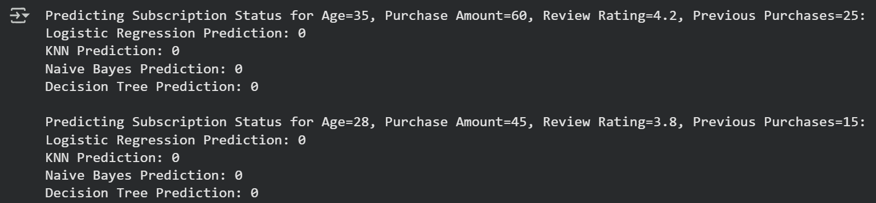
This code trains four models to predict subscription status. The output shows the predicted classes for the test data and two new customers.

12. Evaluate Models using Confusion Matrix and Accuracy
# Step 12: Evaluate Models using Confusion Matrix and Accuracy

# Evaluate models using confusion matrix & accuracy
import pandas as pd
import numpy as np
from sklearn.model_selection import train_test_split
from sklearn.preprocessing import LabelEncoder
from sklearn.metrics import confusion_matrix, accuracy_score, ConfusionMatrixDisplay
from sklearn.linear_model import LogisticRegression
from sklearn.tree import DecisionTreeClassifier
from sklearn.ensemble import RandomForestClassifier
from sklearn.neighbors import KNeighborsClassifier
import matplotlib.pyplot as plt

# 1. Load dataset
df = pd.read_csv("shopping_behavior_updatedNEW.csv")

# 2. Encode categorical columns
le = LabelEncoder()
for col in df.select_dtypes(include="object").columns:
df[col] = le.fit_transform(df[col])

# 3. Define features (X) and target (y)
# Change the target column name if different in your dataset
target_column = 'Purchase Amount (USD)' # Assuming 'Purchase Amount (USD)' is the target based on previous cells
X = df.drop(columns=[target_column])

# Convert 'Purchase Amount (USD)' into a binary target variable based on the median
median_purchase = df[target_column].median()
y = (df[target_column] >= median_purchase).astype(int) # 1 for high purchase, 0 for low purchase

# 4. Split into train/test sets
X_train, X_test, y_train, y_test = train_test_split(X, y, test_size=0.2, random_state=42)

# 5. Define models
models = {
"Logistic Regression": LogisticRegression(max_iter=1000),
"Decision Tree": DecisionTreeClassifier(random_state=42),
"Random Forest": RandomForestClassifier(random_state=42),
"KNN": KNeighborsClassifier()
}

# 6. Evaluate each model
results = {}
for name, model in models.items():
model.fit(X_train, y_train)
y_pred = model.predict(X_test)
acc = accuracy_score(y_test, y_pred)
results[name] = acc
print(f"\n{name}")
print("Accuracy:", round(acc, 4))
cm = confusion_matrix(y_test, y_pred)
disp = ConfusionMatrixDisplay(confusion_matrix=cm)
disp.plot(cmap="Blues")
plt.title(f"{name} - Confusion Matrix")
plt.show()

# 7. Identify and display the best model
best_model = max(results, key=results.get)
print("\nBest Classifier:", best_model)
print("Accuracy:", round(results[best_model], 4))

Output:
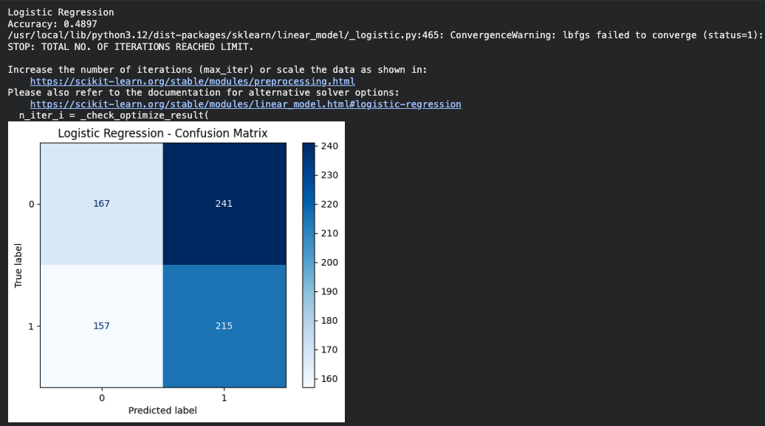
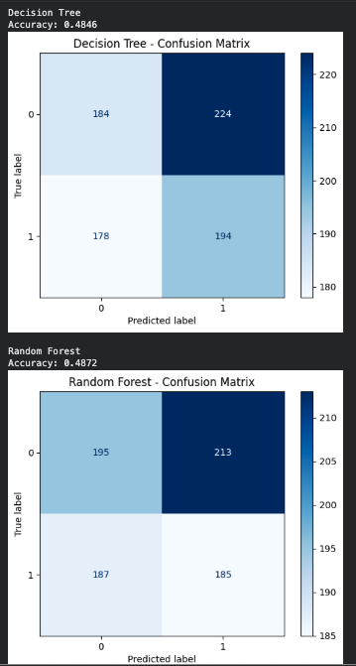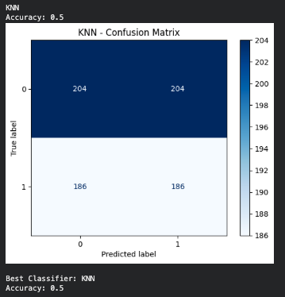
Checks which model predicts best by comparing accuracy and confusion matrices. The output shows each model’s accuracy and the best performer.

13. Predict using Best-Fit Model (Random Forest)
from sklearn.ensemble import RandomForestClassifier

best_model = RandomForestClassifier()
best_model.fit(X_train, y_train)

#Predict on test data
y_pred = best_model.predict(X_test)

#Display sample predictions
predictions = pd.DataFrame({'Actual': y_test, 'Predicted': y_pred})
print("\nSample Predictions:")
print(predictions.head(10))

Output: 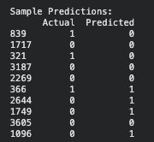
Use the best model (Random Forest) to predict and show the first ten actual vs predicted values. The output is a comparison table.

14. Scatter Plot for Hierarchical Clusters
import pandas as pd
import matplotlib.pyplot as plt
import scipy.cluster.hierarchy as sch
from sklearn.preprocessing import StandardScaler

# Load your dataset
df = pd.read_csv("/content/shopping_behavior_100 copy.csv")

# Select only Age and Purchase Amount
data = df[["Age", "Purchase Amount (USD)"]].dropna()

# Scale data
scaler = StandardScaler()
X = scaler.fit_transform(data)

# Create linkage for hierarchical clustering
linkage_matrix = sch.linkage(X, method="ward")

# Cut the dendrogram into 4 clusters (you can change k)
clusters = sch.fcluster(linkage_matrix, t=4, criterion='maxclust')

# Scatter plot using ONLY the hierarchical cluster labels
plt.figure()
plt.scatter(
data["Age"],
data["Purchase Amount (USD)"],
c=clusters,
s=60
)

plt.title("Hierarchical Clustering (Scatter Plot Only)")
plt.xlabel("Age")
plt.ylabel("Purchase Amount (USD)")
plt.tight_layout()
plt.show()

Output: 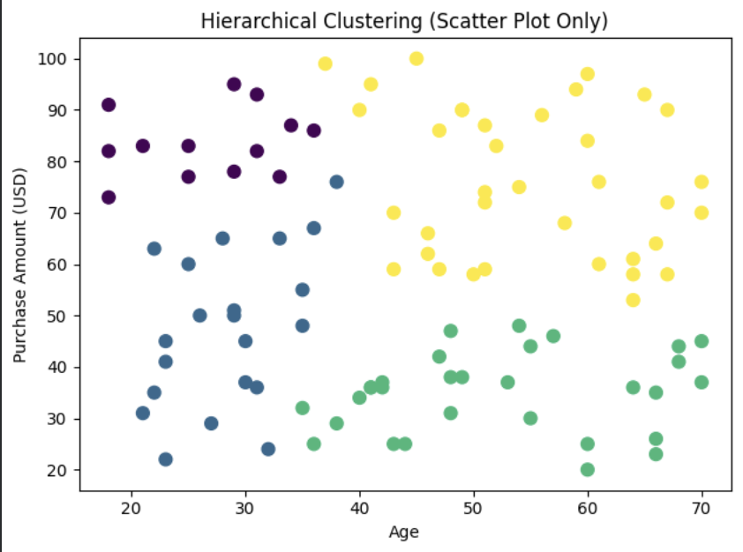
Groups customers into four clusters. The output is a scatter plot showing the four groups.

Hierarchical (Agglomerative) Clustering:
#Hierarchical (Agglomerative) Clustering
import pandas as pd # Import pandas
from scipy.cluster.hierarchy import dendrogram, linkage
import matplotlib.pyplot as plt

# 1. Load dataset
df = pd.read_csv("/content/shopping_behavior_100 copy.csv") # Corrected file path

#Select numeric fields
cluster_data = df[['Age', 'Purchase Amount (USD)']].dropna()

linked = linkage(cluster_data, method = 'ward')
plt.figure(figsize=(8, 4))
dendrogram(linked, orientation = 'top', distance_sort = 'descending', show_leaf_counts = True)
plt.title("Hierarchical Clustering Dendrogram")
plt.xlabel("Age")
plt.ylabel("Purchase Amount (USD)")
plt.show()

Output: 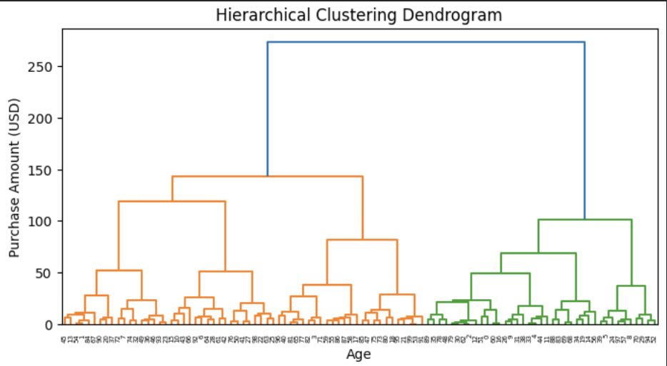
It Builds a dendrogram to show how clusters were formed. The output is the dendrogram chart.

Perform K-means for fields from the dataset:
import pandas as pd
from sklearn.preprocessing import StandardScaler
from sklearn.cluster import KMeans
import matplotlib.pyplot as plt

df = pd.read_csv("/content/shopping_behavior_100 copy.csv")

feature_cols = ["Age", "Purchase Amount (USD)"]

data = df[feature_cols].copy()

scaler = StandardScaler()
X = scaler.fit_transform(data)

k = 4
kmeans = KMeans(
n_clusters=k,
init="k-means++",
random_state=42,
n_init=10,
max_iter=300
)

labels = kmeans.fit_predict(X)

clustered = data.copy()
clustered["Cluster"] = labels

plt.figure()
for c in sorted(clustered["Cluster"].unique()):
plt.scatter(
clustered.loc[clustered["Cluster"] == c, "Age"],
clustered.loc[clustered["Cluster"] == c, "Purchase Amount (USD)"],
s=60,
label=f"Cluster {c+1}"
)

centroids_unscaled = pd.DataFrame(
scaler.inverse_transform(kmeans.cluster_centers_),
columns=feature_cols
)

plt.scatter(
centroids_unscaled["Age"],
centroids_unscaled["Purchase Amount (USD)"],
s=600,
c="yellow",
edgecolors="black",
linewidths=1.2,
label="Centroids",
zorder=5
)

plt.title("K-Means Clustering", fontsize=18)
plt.xlabel("Age")
plt.ylabel("Purchase Amount (USD)")
plt.legend(framealpha=0.9, title=None)
plt.tight_layout()
plt.show()

print("Cluster centroids (original units):")
print(centroids_unscaled)

Output: 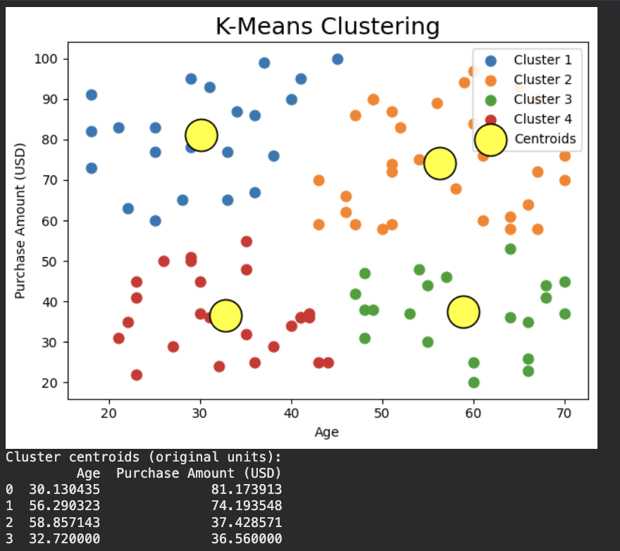
This code makes four clusters using K-Means and plots the centroids. The output is a cluster plot with centers.

Using the Elbow method to find the optimal number of clusters:
import pandas as pd
import matplotlib.pyplot as plt
from sklearn.preprocessing import StandardScaler
from sklearn.cluster import KMeans

df = pd.read_csv("shopping_behavior_100.csv")

feature_cols = ["Age", "Purchase Amount (USD)"]
data = df[feature_cols].dropna().reset_index(drop=True)

# 3) Scale features for K-Means
scaler = StandardScaler()
X = scaler.fit_transform(data)

wcss = []
for k in range(1, 11):
km = KMeans(n_clusters=k, init="k-means++", random_state=42, n_init=10, max_iter=300)
km.fit(X)
wcss.append(km.inertia_)

plt.figure()
plt.plot(range(1, 11), wcss)
plt.title("Elbow Method (Age + Purchase Amount)")
plt.xlabel(" Age (k)")
plt.ylabel("Purchase Amount (USD)")
plt.show()

Output: 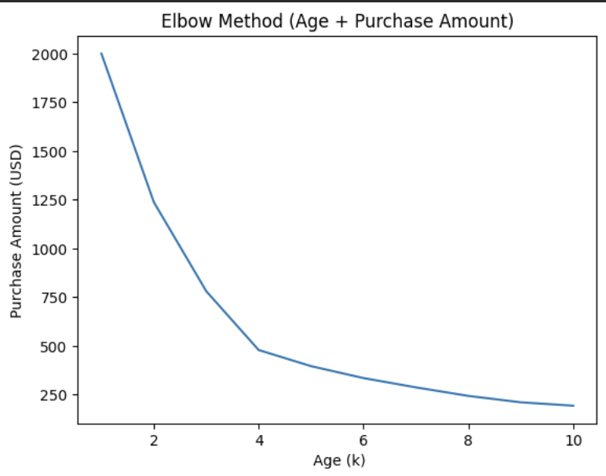
Check different cluster numbers to find the best one. The output is an elbow graph showing the ideal number of clusters.

15. Explain the strategy for improving the system after viewing the cluster diagram:

After analyzing the cluster diagram, it becomes clear that customers can be grouped based on their age and purchase amount into four main segments. Each cluster represents customers with similar buying patterns — for example, younger customers with high spending or older customers with lower purchase amounts.
To improve the system, the next step is to personalize marketing and product recommendations for each group. For instance, promotions can target high-spending clusters to increase loyalty, while lower-spending groups can be offered discounts or bundles to encourage more purchases. Additionally, collecting more data such as income, gender, or visit frequency could help make the clustering more accurate.
Finally, by combining clustering insights with classification models (like Random Forest or KNN), the system can predict future customer behavior and automatically group new customers into the right cluster, improving decision-making and overall business performance.

Task 4:
In this final step, we uploaded all our files and projects in GitHub:

16. Create a new repo for project in Git Hub
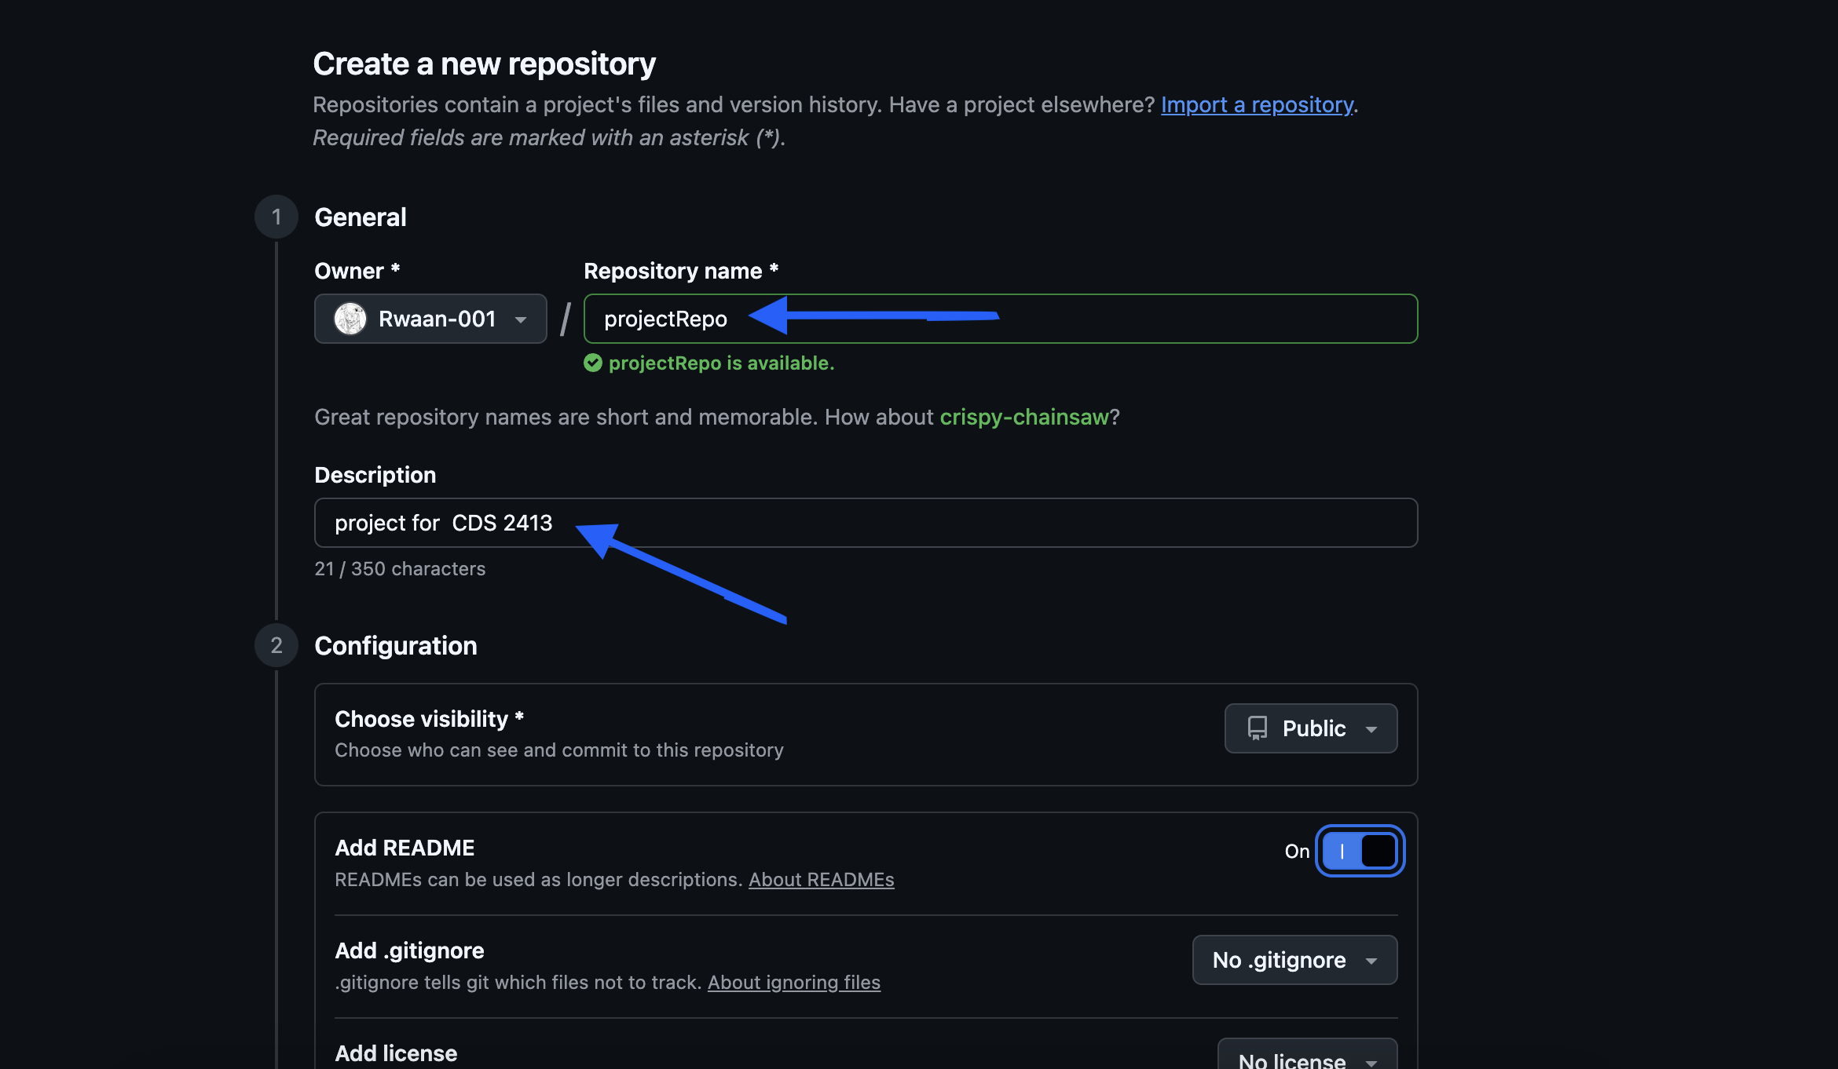

17. Upload all the project files created for CLO1,CLO2 and CLO3 to the Git Hub repo

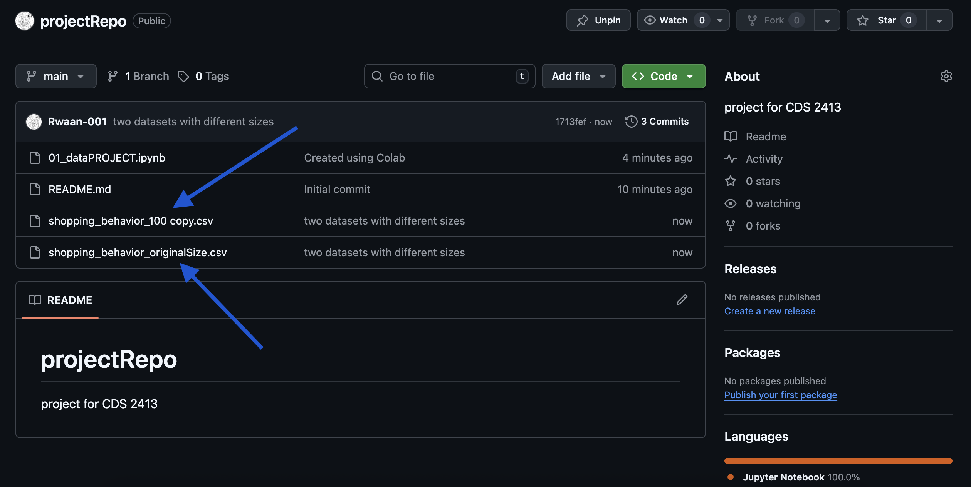

18. Configure Git with GitHub

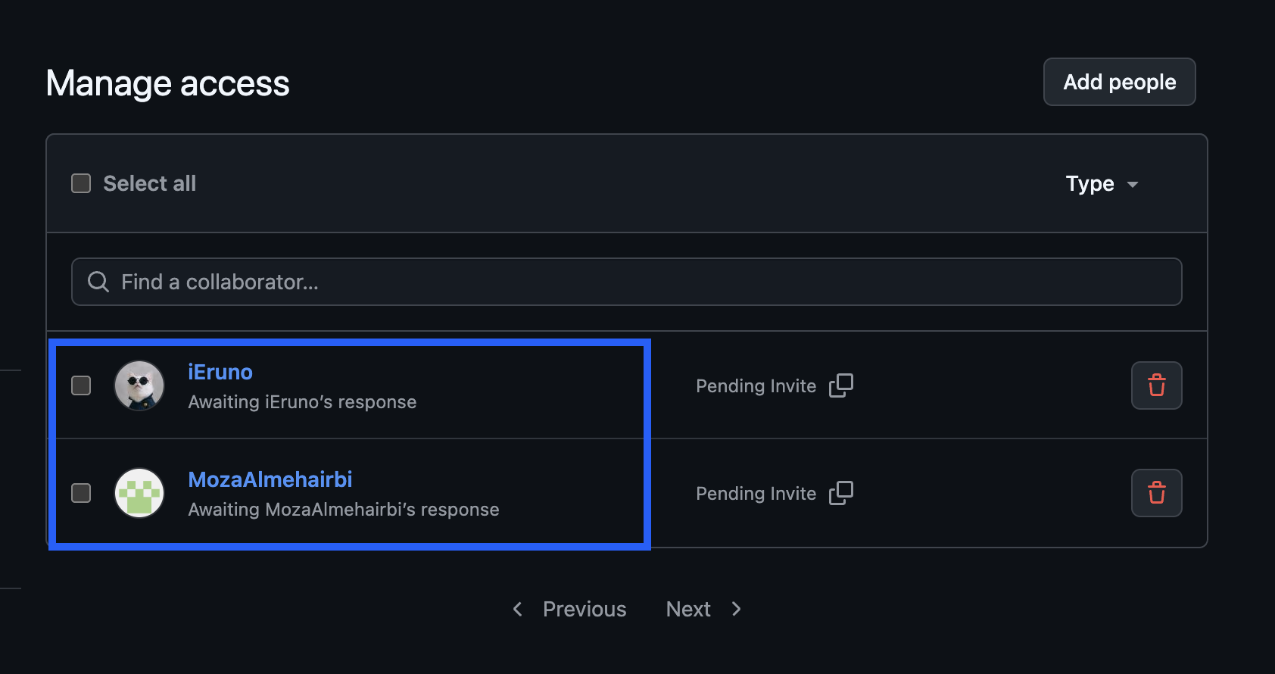

19. Clone Git hub repo to Git

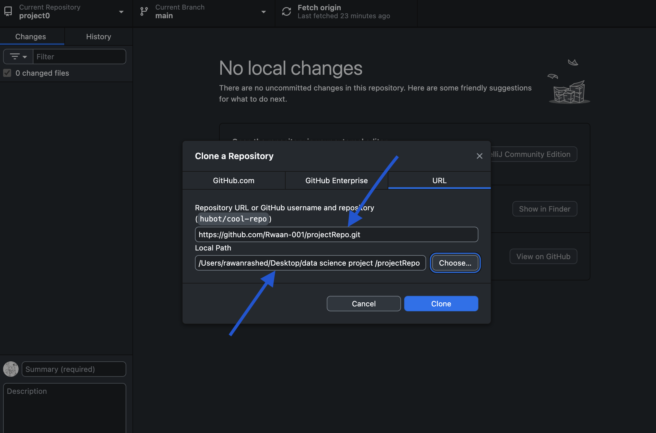

20. Pull any file from Git Hub repo to Git

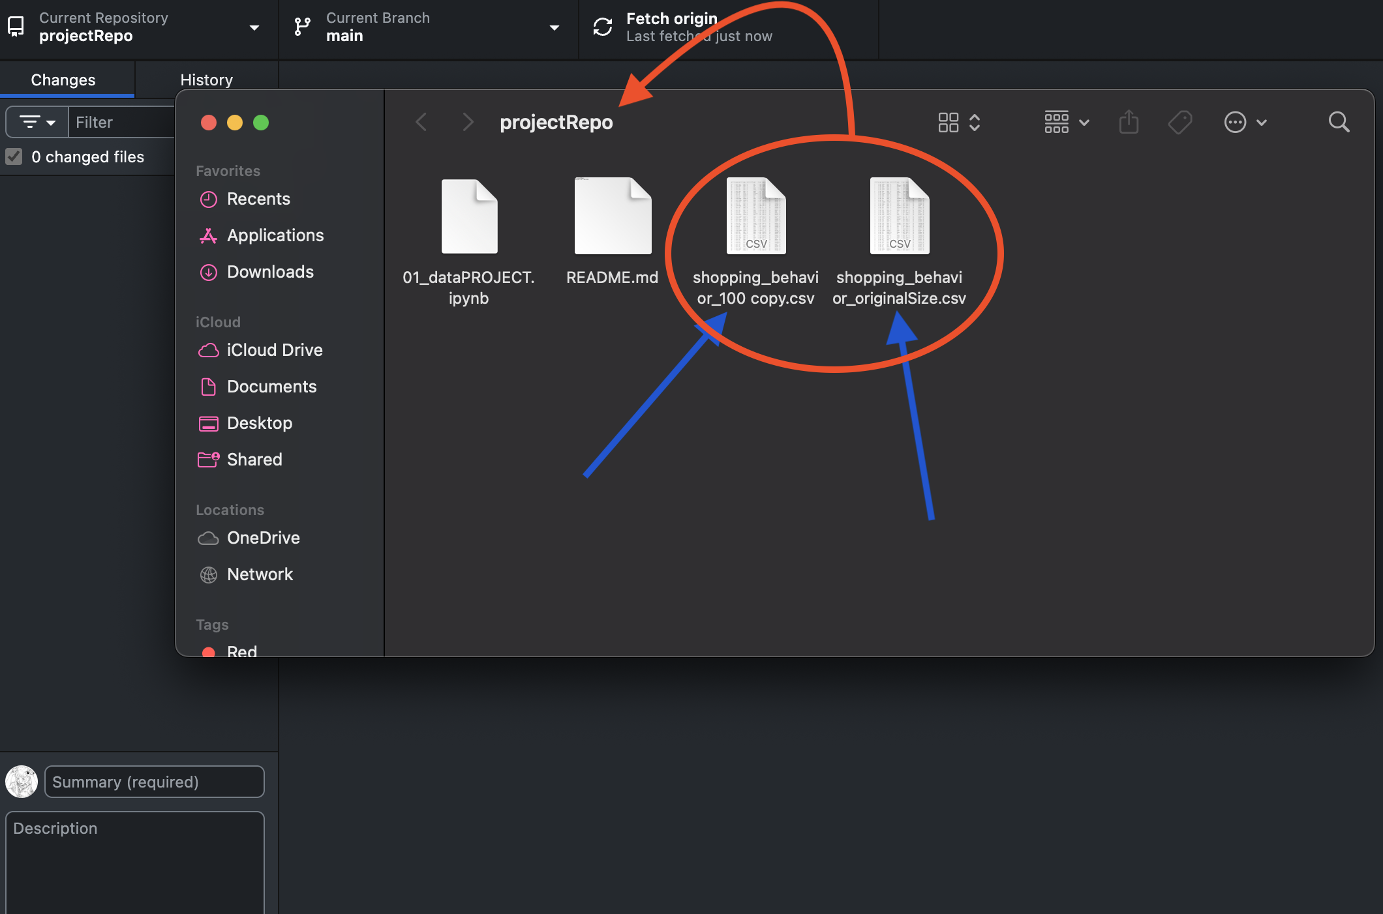

21. Modify the pulled file and push the modified file to Git Hub

